**Assignment No:-54**

Name:-Suryawanshi Sangramsingh Sambhaji

Batch: - Delta - DCA (Java) 2024 Date:-29/7/2024

**MYSQL PLACEMENT CENTRIC QUESTIONS:**

CREATE TABLE employees (

employee_id INT PRIMARY KEY,

first_name VARCHAR(50),

last_name VARCHAR(50),

department VARCHAR(50),

salary DECIMAL(10,2)

);

INSERT INTO employees (employee_id, first_name, last_name, department, salary)

VALUES

(1, 'John', 'Doe', 'IT', 60000.00),

(2, 'Jane', 'Smith', 'HR', 55000.00),

(3, 'Bob', 'Johnson', 'Finance', 70000.00),

(4, 'Eva', 'Brown', 'Marketing', 62000.00),

(5, 'Michael', 'Clark', 'IT', 75000.00),

(6, 'Emily', 'Jones', 'Finance', 68000.00),

(7, 'Alex', 'Miller', 'HR', 58000.00),

(8, 'Sophia', 'Wilson', 'Marketing', 67000.00),

(9, 'Daniel', 'Lee', 'IT', 72000.00),

(10, 'Olivia', 'Davis', 'Finance', 71000.00),

(11, 'William', 'Garcia', 'Marketing', 63000.00),

(12, 'Ava', 'Martinez', 'HR', 59000.00),

(13, 'James', 'Taylor', 'IT', 68000.00),

(14, 'Mia', 'Anderson', 'Finance', 70000.00),

(15, 'Benjamin', 'Hill', 'Marketing', 64000.00),

(16, 'Emma', 'White', 'HR', 60000.00),

(17, 'Liam', 'Harris', 'IT', 71000.00),

(18, 'Chloe', 'Moore', 'Finance', 69000.00),

(19, 'Noah', 'Clarkson', 'Marketing', 66000.00),

(20, 'Grace', 'Cooper', 'IT', 73000.00);

**Question on Subquery:**

1. Retrieve employees who have a salary greater than the average salary in the IT department.

select * from employees where salary >(select avg(salary) from employees where department ='IT');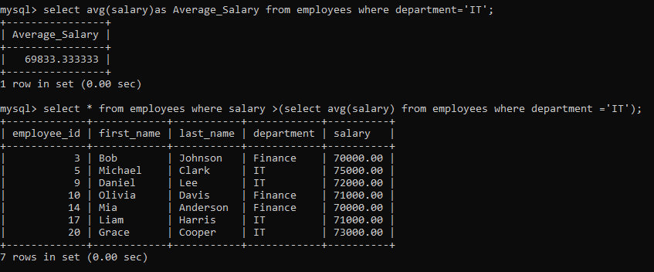

2. Find employees whose last name is the same as the manager's last name in the

Finance department.

select * from employees where department='Finance' and first_name like '%e' OR (select department from employees where department ='HR' AND last_name like '%e');

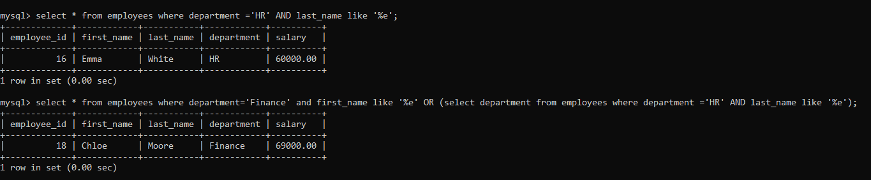

3. Identify employees who work in departments with more than five employees.

select count(department)As Department_Count from employees group by department having count(employee_id)>5;



4. List employees who have a salary greater than the highest salary in the Marketing

department.

select * from employees where salary>(select max(salary) from employees where department ='marketing');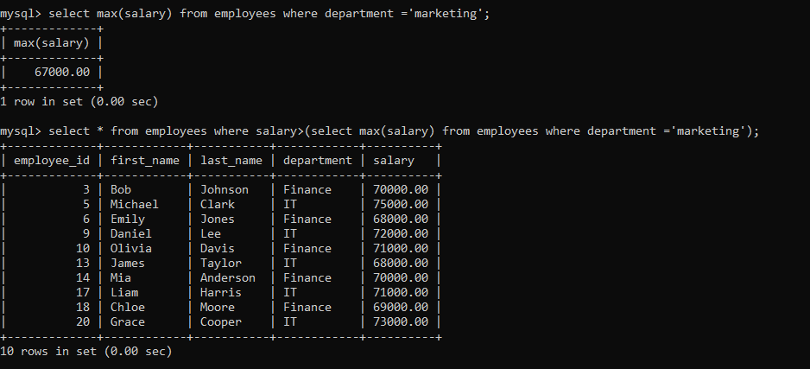

5. Select employees whose salary is within 10% of the highest salary in the company.

select * from employees where salary>=(select max(salary)*0.9 from employees);

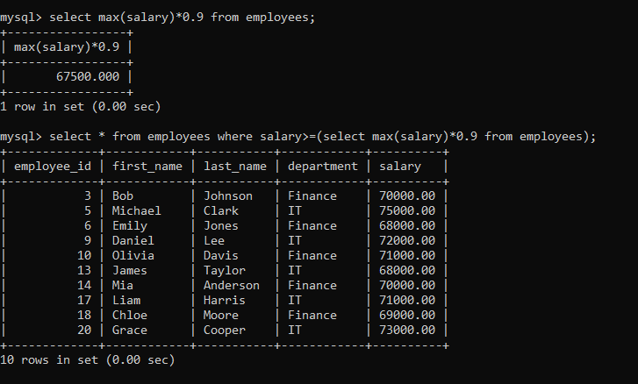

6. Find employees who do not have a manager.

select * from employees where department !='HR';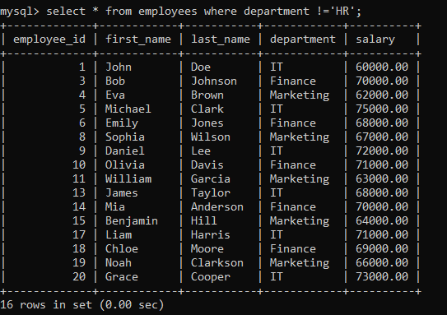

7. List departments where the average salary is greater than the average salary in the

IT department.

select avg(salary)as average_salary from employees where salary>(select avg(salary) from employees where department ='IT');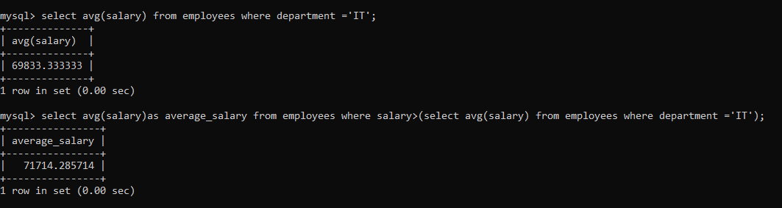

8. Retrieve employees who have the same first name as their manager.

select * from employees (select first_name from employees where first_name like %a);

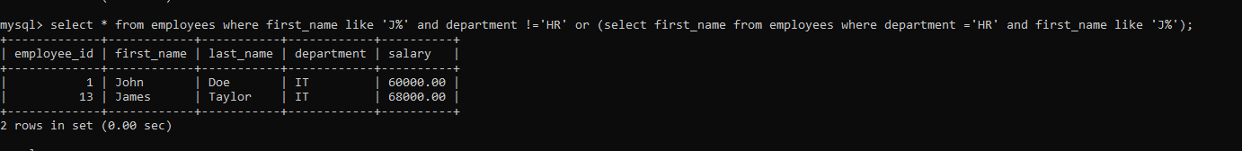

9. Identify employees who have a salary higher than the average salary of their

department.

select * from employees where salary >(select avg(salary) from employees) order by salary desc;

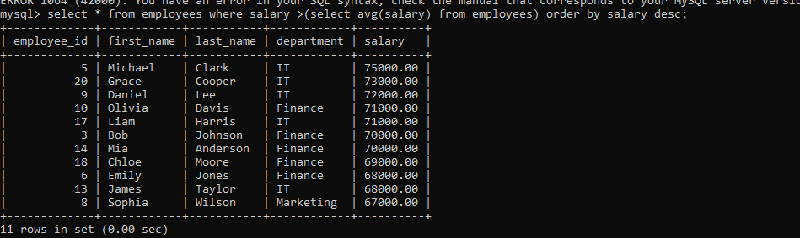

10. Find employees who have a higher salary than anyone in the HR department.

Select * from employees where department !='HR' and salary >(select avg(salary) from employees where department ='HR');

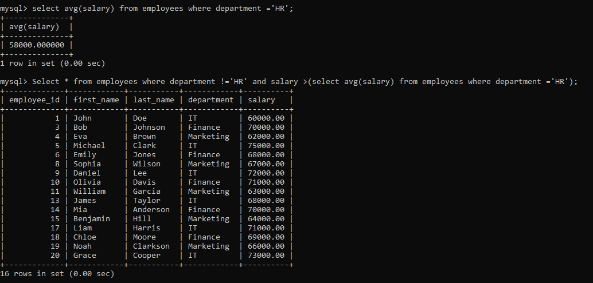

11. List departments where the total salary is greater than the total salary in the Finance department.

Select * from employees where department !='Finance' and salary >(select avg(salary) from employees where department ='Finance');

12. Retrieve employees who do not belong to any department.

Select * from employees where department is null;



13. Find employees who joined after the employee with the highest salary.

select * from employees order by salary desc limit 1 offset 1;

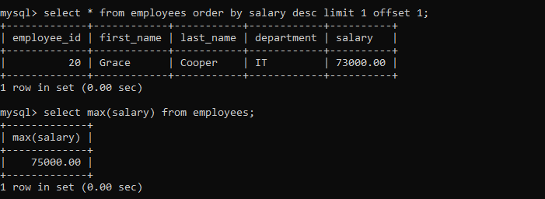

14. List employees whose salary is greater than the average salary of employees in the

same department.

select * from employees where department ='IT' and salary>(select avg(salary) from employees where department ='IT');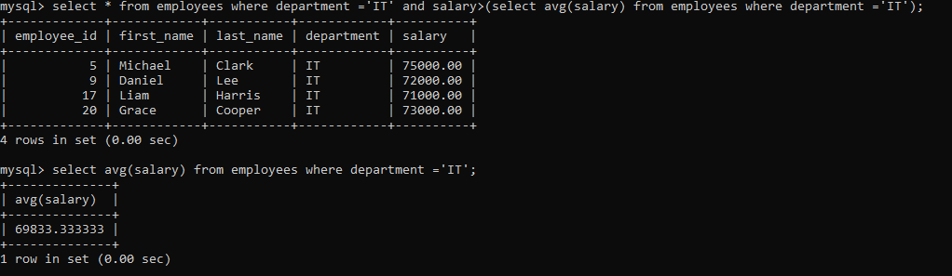

15. Select departments with more than three employees earning a salary greater than

$60,000.

select department FROM employees WHERE salary > 60000 group by department having count(employee_id)>3;

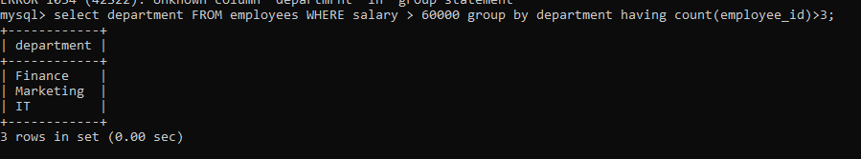

16. Retrieve employees who have a salary higher than the average salary of employees

with the same job title.

select * from employees d WHERE salary >(select avg(salary) from employees where department=d.department);

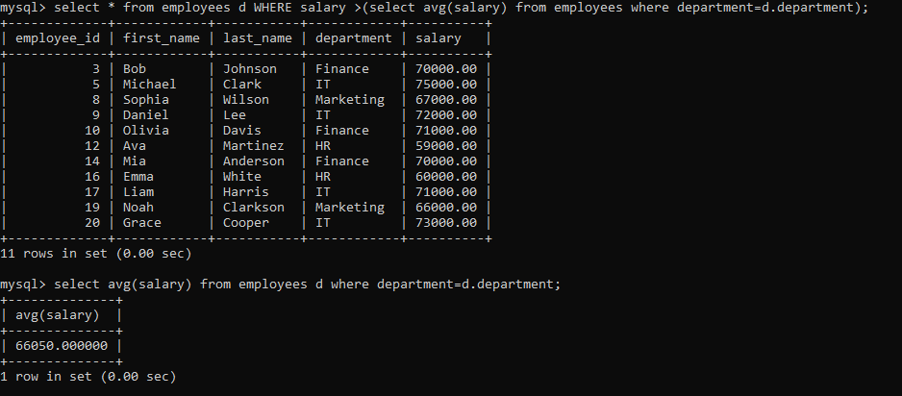

17. Find employees who have a salary higher than the average salary of their

department and joined after 2020.

18. List employees who have the same salary as at least one employee in the IT

department.

select * from employees where department !='IT' and salary in(select salary from employees where department ='IT');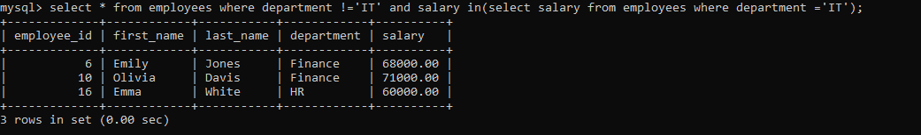

19. Identify employees who have a salary higher than the average salary of employees

with the same manager.

select * from employees where department !='HR' and salary >(select avg(salary) from employees where department='HR');

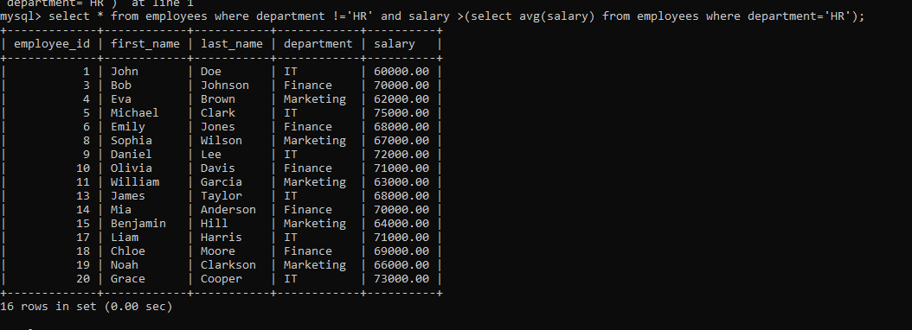

20. Retrieve employees who have a salary higher than the average salary in their

department and belong to the IT department.

select * from employees d where department='IT' and salary >(select avg(salary) from employees where department=d.department);

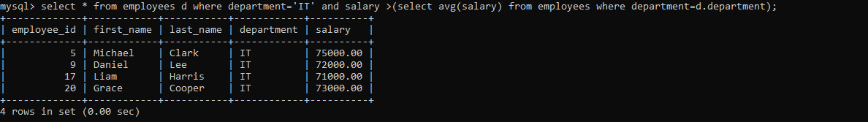

**Question on Limit:**

1. Retrieve the first 5 employees in the table.

select * from employees limit 5;



2. List the top 10 highest-paid employees.

select * from employees order by salary desc limit 10;

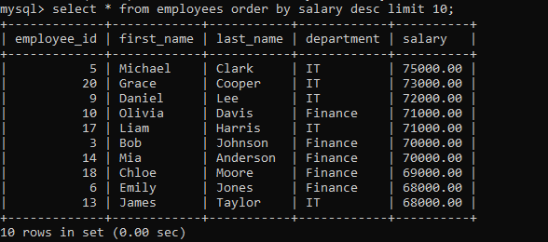

3. Select the first 3 departments in alphabetical order.

select * from employees order by department desc limit 3;

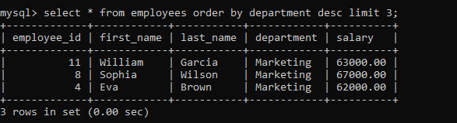

4. Retrieve the oldest 8 employees based on their hire date.

5. List the 5 departments with the most employees.

select department from employees group by department having count(department)>5;

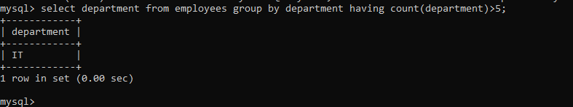

6. Select the first 5 employees in the HR department.

select * from employees where department=’HR’ limit 5;

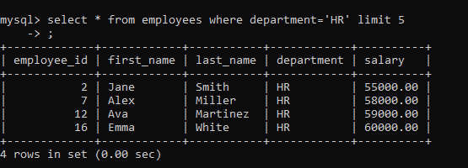

7. Retrieve the 3 employees with the lowest salaries.

select * from employees order by salary limit 3;

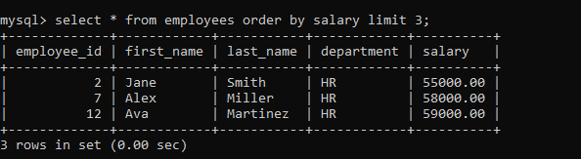

8. List the top 7 departments with the highest average salary.

select department,avg(salary) from employees group by department limit 7;

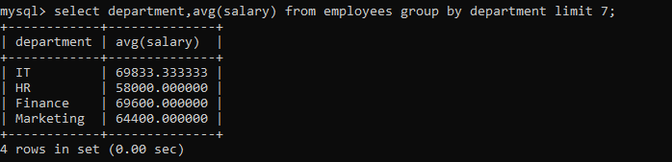

9. Select the first 4 employees who joined the company in the year 2021.

10. Retrieve the 6 employees with the highest salaries in the Finance department.

select * from employees where department='Finance' order by salary desc limit 6;

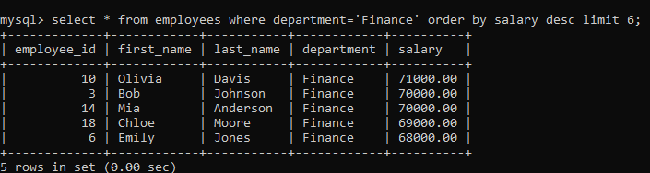

**Questions on Conditions:**

1. Select employees who work in the IT department.

select * from employees where department=IT;

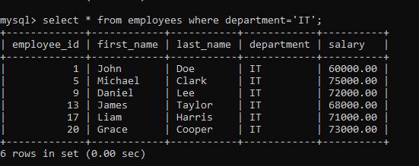

2. Retrieve employees with a salary greater than $60,000.

select * from employees where salary >60000;

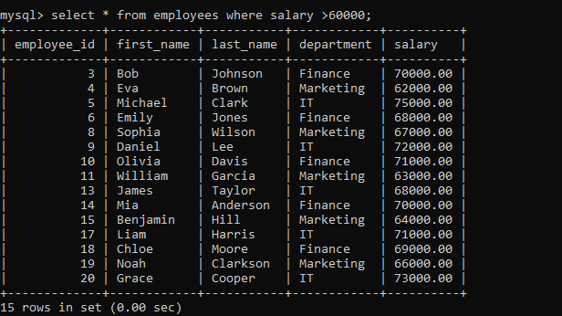

3. List employees hired after January 1, 2022.

4. Find employees whose last name starts with 'S'.

select * from employees where last_name like 's%';

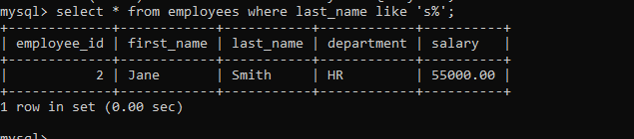

5. Select employees who do not belong to any department.

select * from employees e where department!=e.department;



6. Retrieve employees whose first name is either 'John' or 'Jane'.

select * from employees where first_name in('John' ,'Jane');

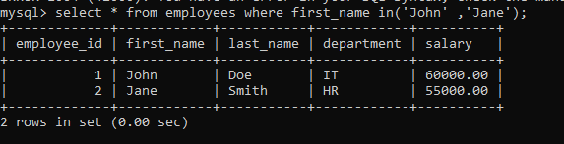

7. List employees who have 'Manager' in their job title.

select * from employees e where department='HR';

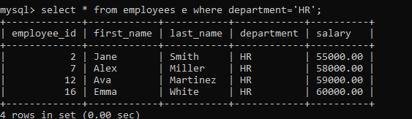

8. Find employees who joined before the year 2021 and have a salary greater than

$50,000.

9. Select employees who work in the Finance department and have a salary greater

than $70,000.

select * from employees where department='Finance' and salary >70000;

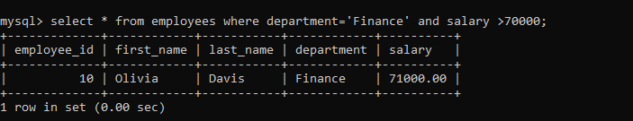

10. Retrieve employees who do not have a manager.

select * from employees e where department !='HR';

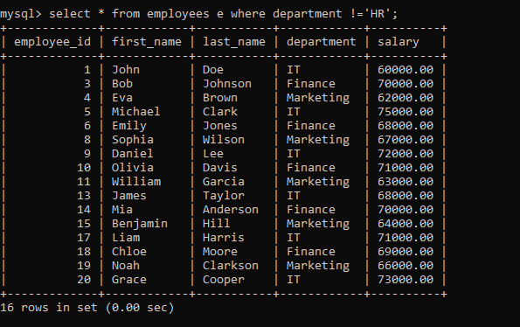

**Questions on Alter statement:**

1. Add a new column named "birth_date" to the employees table with the data type

DATE.

Alter table employees add birth_date date;

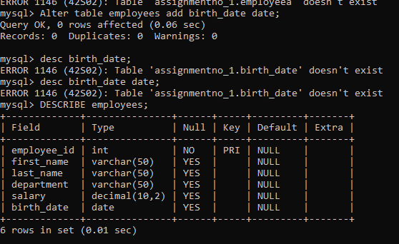

2. Modify the data type of the "salary" column to accommodate larger values.

Alter table employees modify salary bigint;

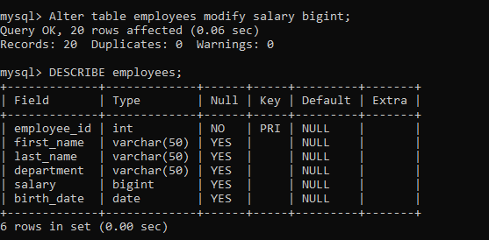

3. Rename the "department" column to "dept" in the employees table.

Alter table employees rename column department to dept;

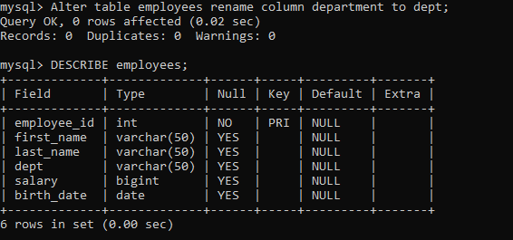

4. Add a NOT NULL constraint to the "email" column.

Alter table employees add email varchar(30) NOT NULL;

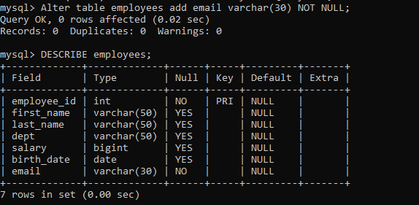

5. Drop the "birth_date" column from the employees table.

Alter table employees drop column birth_date;

